Title: Designing an AWS Event Analytics Pipeline with Glue, Spark, and Athena

Introduction:
Modern applications collect a lot of behavioral data like which products people look at, how they move through the site, when they add things to the cart, and what they eventually buy. Those events are extremely useful for product and analytics teams, but not in their raw form. Large JSON log files sitting in S3 are hard to query directly, slow, and expensive to scan over and over.
For this capstone, I built a small but realistic event analytics pipeline on AWS. The goal was to take high volume e-commerce events written into S3 every few minutes, process them incrementally with AWS Glue and Spark, store them in a structured and efficient format, and make them easy to query with Athena. On top of that, I had to support five concrete business questions around funnels, revenue, popular products, category activity, and user engagement.
What follows is how I approached the problem, what I built, and what I learned along the way.
- Problem Setup and Goals
The starting point for the project was an S3 bucket that receives synthetic e-commerce events. An AWS Lambda function, triggered on a schedule, writes between 500000 - 750000 events every five minutes. Each event describes a user action - viewing a product, adding or removing items from the cart, completing a purchase, or running a search.
The raw data has a reasonably rich schema. Every record includes:
- Timestamp
- User and session identifiers
- Event type (view, cart, purchase, search)
- Product and category information where relevant
- Quantity and price for cart and purchase events
- Search queries for search events
The catch is that this data arrives as compressed JSON Lines files and keeps growing over time. Querying it as is in Athena would work, but it would be slow and would scan far more data than necessary, especially as the dataset grows.
The core goals for my pipeline were:
- Ingest and store the raw events in a structured way on S3.
- Build an ETL job that can be rerun as new data arrives, without reprocessing everything.
- Produce a clean, typed Parquet dataset partitioned by time.
- Register that dataset in the Glue Data Catalog and query it from Athena.
- Answer five specific business questions using SQL on top of the final dataset.
I wanted the end result to be something I could explain like a real system, not just a one off script.
2. Overall Architecture
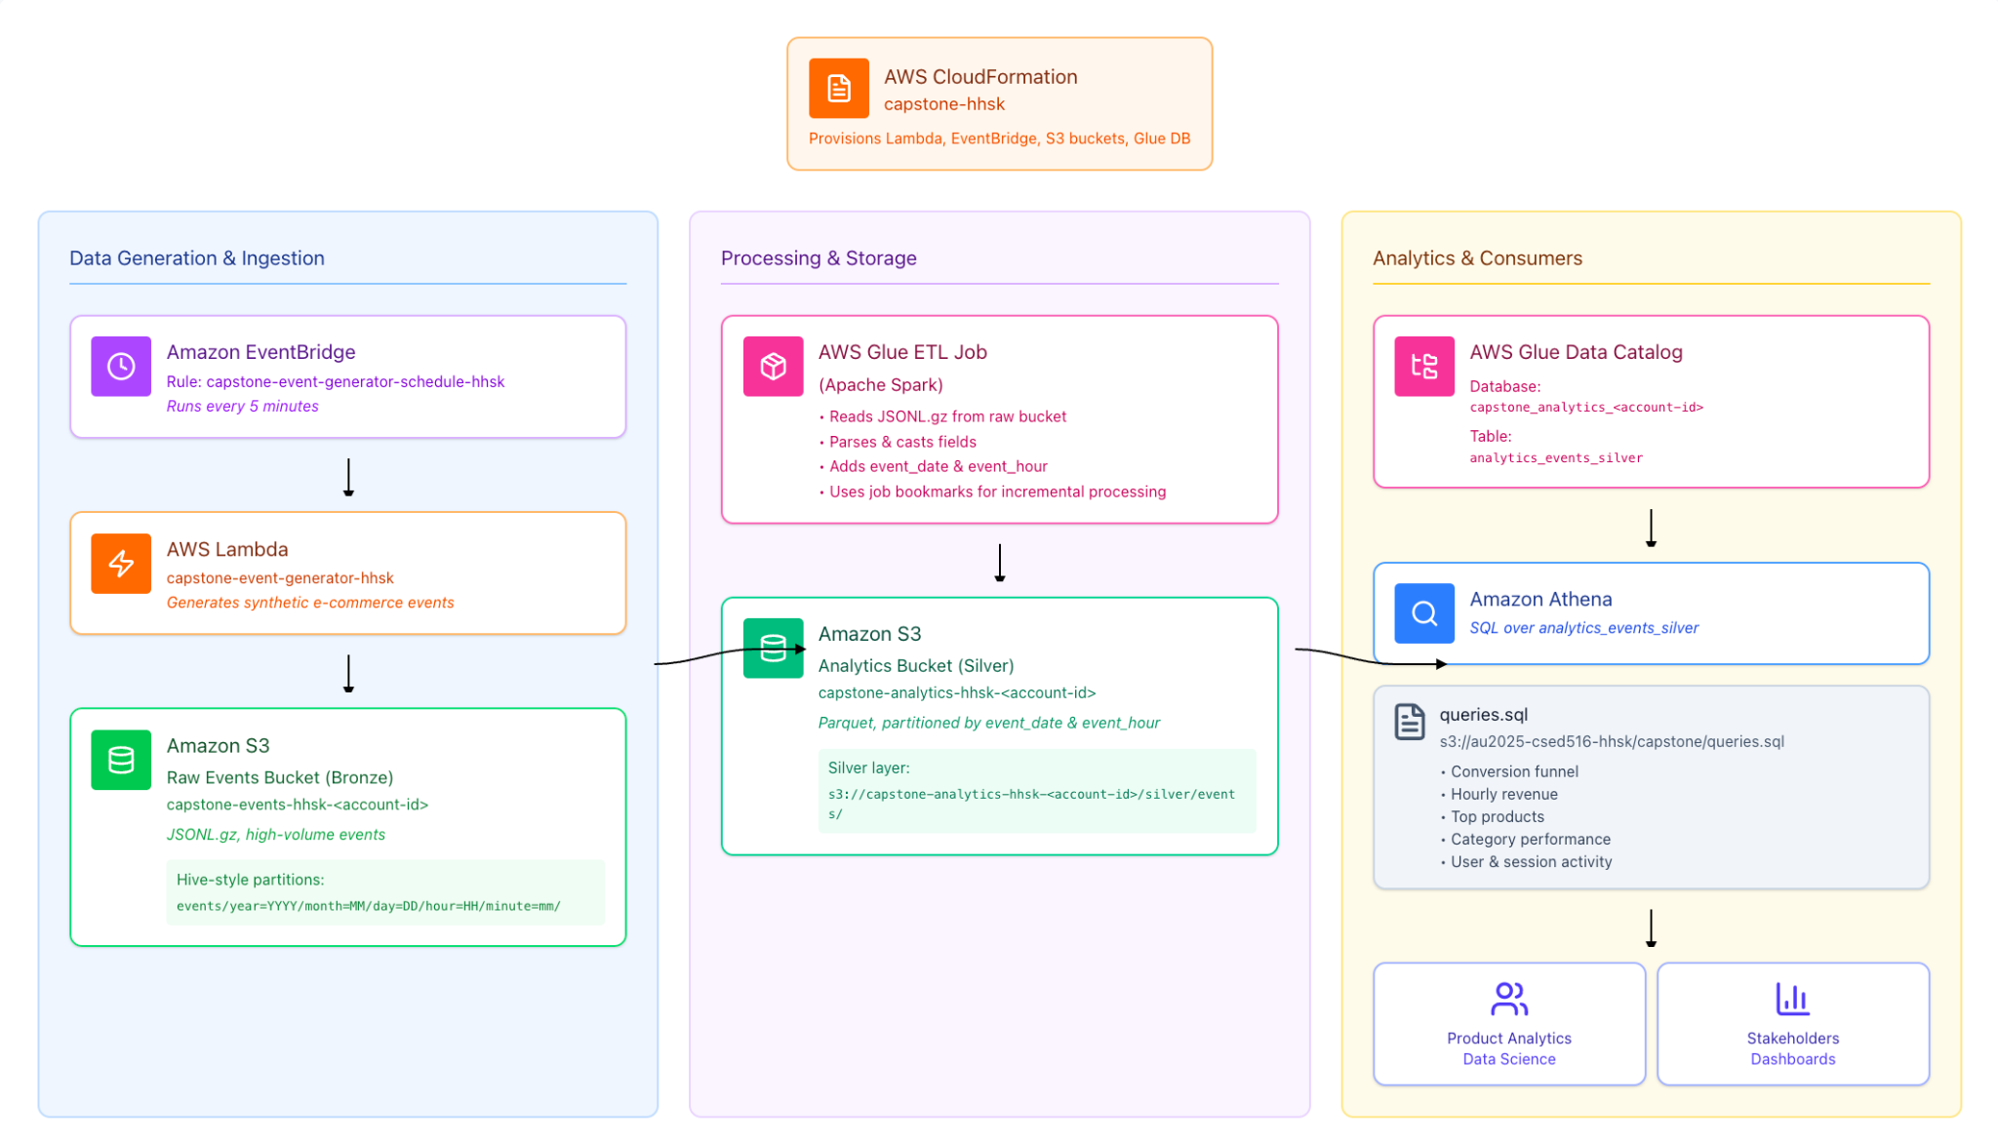
At a high level, the pipeline flows through three main stages:
- Event generation and raw storage
  - An EventBridge rule runs every five minutes.
  - It triggers a Lambda function that generates synthetic events and writes them to a “raw” S3 bucket.
- Processing and curation
  - An AWS Glue job running on Spark reads the raw JSONL.gz files.
  - It applies transformations and writes cleaned data as partitioned Parquet into a separate “analytics” S3 bucket.
- Query and analytics
  - The AWS Glue Data Catalog holds the schema and table definition for the analytics dataset.
  - Amazon Athena queries that dataset using standard SQL, powering the five required analyses.
In my architecture diagram (which I created in a tool called Figma and embedded into the blog), I show each of these components as separate boxes with arrows between them: EventBridge and Lambda feeding the Bronze (raw) S3 bucket, Glue and Spark transforming that into a Silver (curated) bucket, and Athena sitting on top via the Glue Data Catalog.

3. Raw Data in S3: How Events Are Stored
The ingestion layer writes data into S3 as gzipped JSON Lines files. Each file contains hundreds of thousands of events. The file layout is not arbitrary, it uses a time-based folder structure that looks like this at a high level:
events/year=YYYY/month=MM/day=DD/hour=HH/minute=mm/events-<timestamp>.jsonl.gz
This pattern is often called a Hive-style layout. The important detail is that the time components (year, month, day, hour, minute) are encoded in the folder names in a consistent way. Later, Glue and Athena can interpret those as partition values.
I treat this S3 bucket as the “raw” or Bronze layer. It stores exactly what the generator wrote, compressed for space, with no transformations beyond the folder layout. If anything ever went wrong downstream, this is the place to go back to.
4. Building the ETL with Glue and Spark
The middle of the pipeline is where most of the logic lives. I used an AWS Glue job running on Spark to turn the raw JSON logs into a clean analytical dataset.
The Glue job takes the source bucket and the analytics bucket as parameters. Inside the script,
- Point the input to the events prefix in the raw bucket.
- Point the output to a “silver/events” prefix in the analytics bucket.
The job then performs several steps.
First, it reads the JSON files into a Glue DynamicFrame. This object type integrates nicely with Glue’s internal features such as job bookmarks, and it can handle semi-structured data. Using recursive read options, the job pulls in all relevant files under the events hierarchy.
Second, I convert the DynamicFrame to a standard Spark DataFrame. This lets me use Spark’s DataFrame operations and built-in functions. On this DataFrame I,
- Parse the string timestamp into a proper timestamp column.
- Derive an event_date string (for example “2025-12-07”).
- Derive an event_hour string (for example “01”).
- Cast quantity to integer and price to double.
These steps give me a clean schema and add the columns that I want to use as partition keys later.
Finally, I write the DataFrame out to S3 as Parquet files, partitioned by event_date and event_hour, using append mode. The result is a set of Parquet files in the analytics bucket organized by date and hour.
Spark turned out to be helpful here because it let me bundle parsing, cleaning, and partitioning into a single job, while AWS Glue handled provisioning the execution environment and integrating with S3 and the Data Catalog.
5. Handling New Data with Job Bookmarks
The pipeline needed to be able to run multiple times as new raw files appeared. Re-reading the entire raw bucket on every run would be wasteful and could introduce duplicate records in the Silver dataset.
To avoid that, I used AWS Glue’s job bookmark feature. When bookmarks are enabled, Glue keeps track of which S3 objects have already been processed by a given job. The next time the job runs, it can skip those objects and focus only on new files.
In my configuration, the job bookmark state is tied to the events prefix in the raw bucket. On the first run, all existing jsonl.gz files are read and processed. If more data is generated later and the job runs again, Glue bookmarks ensure that only the new raw files are ingested.
Job bookmarks are simple in concept but important in practice. They turn the job from “batch script that redoes everything” into “incremental pipeline that keeps up with new data.” At the same time, they require a bit of care, if input paths or settings change unexpectedly, it is possible to misread or miss data. Because of that, I double checked row counts and partitions after running the job multiple times.
6. Turning Parquet into a Queryable Table
After the Glue job runs, the Silver dataset lives in the analytics bucket under a structure like:
silver/events/event_date=YYYY-MM-DD/event_hour=HH/…
Within each partition directory, there are Parquet files containing the transformed events. This format is both compressed and columnar, which is ideal for analytics.
To make this dataset accessible to analysts and to my own queries, I used the AWS Glue Data Catalog and Amazon Athena.
The CloudFormation template created a dedicated Glue database for analytics. With that in place, I defined an external table whose location points to the Silver S3 prefix. The schema of the table matches what the Glue job produces, the original event fields along with the event_timestamp column, and the event_date and event_hour as partition columns.
After creating the table, I ran a repair operation in Athena. This scans the S3 folder hierarchy and registers all existing partition directories as table partitions. Once that step is done, Athena can prune partitions efficiently and only scan the relevant slices of data.
I validated this part by running simple group-by queries on event_date and event_hour and confirming that the row counts lined up with what I expected from the volume of raw events.
7. Answering Analytics Questions with SQL
With the Silver table in place, I implemented the five analytical queries the assignment required and stored them together in a single SQL file.
The first query looks at the product conversion funnel. It aggregates events by product and counts how many times each product was viewed, added to cart, and purchased. From those counts, it computes conversion rates between the stages. This gives a product level view of how efficiently traffic turns into purchases.
The second query calculates hourly revenue. It filters to purchase events, computes price multiplied by quantity for each event, and sums that by event_date and event_hour. The result is a time series that shows how much revenue flows through the system each hour.
The third query identifies the most viewed products. It focuses on view-type events, counts them per product, and orders by count to find the top products by attention.
The fourth query examines category-level activity. It groups events by date and category and counts the number of events per group. This helps answer questions like “which categories see the most interaction over time?”. Events without a category are grouped under a placeholder value so they are still visible.
The fifth query focuses on user and session activity. It groups by event_date and counts distinct users and distinct sessions for each day. This is a straightforward way to monitor daily activity and engagement trends.
All of these queries run on top of the same Silver dataset. That was an explicit design goal: instead of building separate pipelines for each question, I created one curated table that supports multiple analytics use cases.
8. Validation, Debugging, and Practical Details
Getting the pipeline to work end-to-end required a fair amount of verification and troubleshooting beyond just writing the core logic.
On the validation side, I compared row counts between the raw and Silver layers and checked that rerunning the Glue job did not accidentally double-count data. After collecting an initial hour of events, I ran the ETL job and noted counts by date and hour. If more events were generated afterwards and the job ran again, I checked that existing partitions remained unchanged while new partitions gained additional rows. That confirmed that job bookmarks were working as intended.
On the debugging side, I ran into a few classic AWS issues: making sure I used the exact bucket and prefix names defined by CloudFormation, remembering to run partition repair in Athena before expecting to see data, and being careful with IAM roles when configuring the Glue job. None of these are complicated on their own, but resolving them gave me a better understanding of how the services connect.
Finally, I was conscious of cost and resource usage. Because the event generator runs on a fixed schedule, it will happily continue writing files forever. After I had enough data to support the assignment and my own validation, I disabled the EventBridge rule. That stopped the Lambda invocations while leaving the existing events and pipeline intact for queries and grading.
9. What I Learned and How I Would Extend It
This project helped me connect a lot of individual AWS concepts into a coherent story.
I now have a much more concrete picture of where Spark on Glue fits in: it is the engine that takes me from logs in S3 to a structured, partitioned dataset that downstream tools can use. Parquet and partitioning went from “recommended best practice” to “obviously necessary” once I saw how they affect Athena’s scan cost and responsiveness. Glue job bookmarks showed me a simple way to make an ETL job incremental, while also reminding me that those kinds of features need to be validated, not just turned on.
If I were to extend this pipeline, there are a few clear directions:
- Automate the ETL trigger so the Glue job itself runs on a schedule.
- Add monitoring and alerts for ETL failures or unexpected row count drops.
- Introduce a dedicated Gold layer with pre-aggregated tables for dashboards or BI tools.
- Experiment with alternative designs, such as using Athena CTAS statements instead of Glue for simpler transformations, and compare the trade-offs.
Overall, this project gave me something I can talk through in detail: from how the events are generated and stored, to how they are processed, to how they are queried.

